RESEARCH ASSIGNMENT CHEMISTRY unit 4

TYPE – RESEARCH

OUTCOMES TO BE ASSESSED:
Outcome 1: Investigating and Communicating

Outcome 2: Structure, Properties and Uses of Materials

Outcome 3: Interaction and Change

ESSENTIAL CONTENT - UNIT 4
The practice of chemistry
Chemical processes
Chemistry and Modern Lifestyles
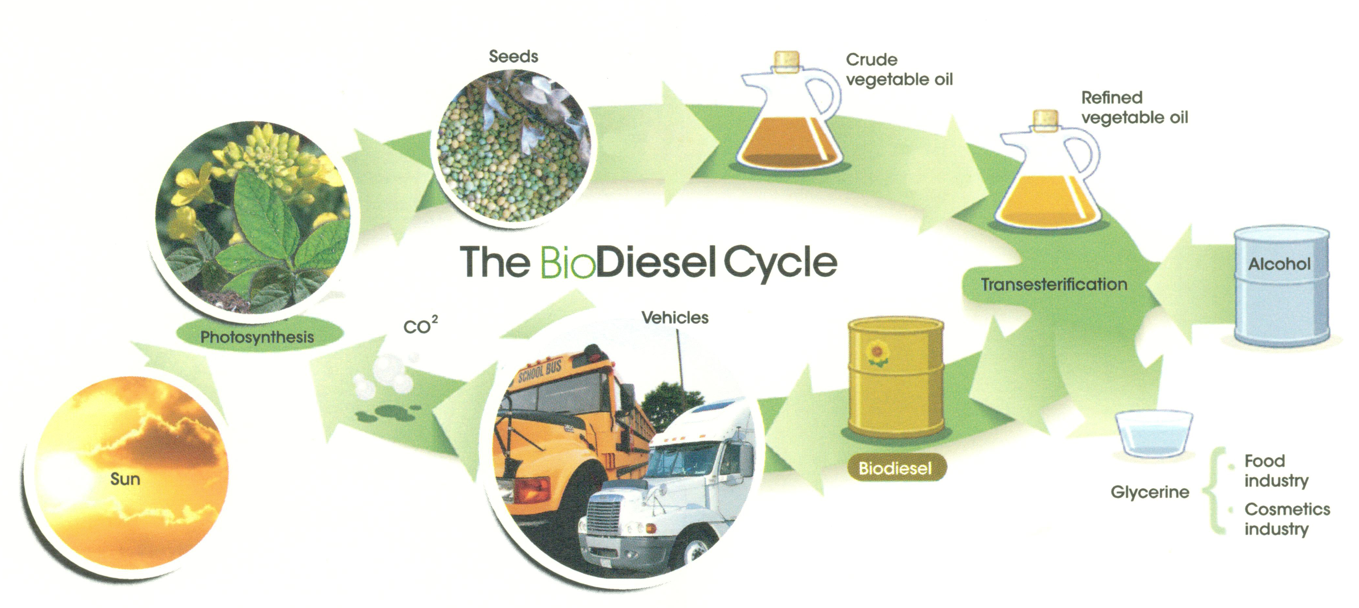
Overview: Biodiesel / The Contact process
Diesel fuel accounts for 38% of transport fuel used in Australia and is almost entirely derived from fossil fuels. Consideration into the use of biofuels as a replacement fuel or as an additive to diesel has been made over a number of years. At present the major biofuel used in the European Union is biodiesel which is produced by the transesterifcation of bio-oils.
Sulfuric acid is one of the mostly widely used chemicals in the world, both in the manufacture of phosphate fertilizers, but also as an oxidising agent in the extraction of metal from their ores throughout the mining industry in Australia. Sulfuric acid is manufactured almost exclusively by the Contact process.

TASK:

Research the chemistry of Biodiesel manufacture and the transesterifcation process. In the second part of the assignment research the Contact process and what factors affect the yield and rate of sulphuric acid production. Use the stimulus questions to devise section headings and present your research as concise notes with appropriate content, illustration and animation in the sequence prescribed below:

- Detail the processes and chemistry in the production of biodiesel? Some methods of production are often referred to as a base-catalysed esterification, outline the synthetic reaction in terms of yield.

- Lipase is an enzyme found in most living things, and in humans it catalyses the breakdown of fats and oils. Investigate the research and trials relating to the use of lipase-catalysed esterification as a more cost effective method of producing biodiesel.

- The Contact process involves multi stages via an intermediate called oleum. Detail this process.

- Review the conditions that affect the reaction rate, stage 2 is reversible and discuss the conditions that maximise yield, and uses of sulfuric acid.

- You will be assessed on your six-page A4 research document as well as your written answer to two “Open” validation questions that will be completed in class. You WILL be able to use your six-page A4 research document to help in completing the validation questions.

Outcome 1 aspect 4 Outcome 2 aspects 1,2,3 and 4

What needs to be in your folio for assessment? | Due date
▢ Six pages A4 notes ▢ Open ended question response

